1. Write a program to depict the usage of the Lambda expression.
2. Write a program using the StringJoiner with example.
3. Write a program to depict the Optional class.
4. Show case the usage of forEach()
5. Write a program to showcase the usage of streams and method references.

Answers

1.

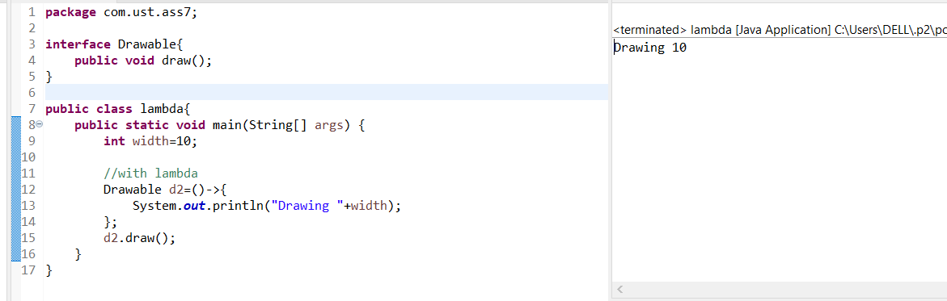

2.

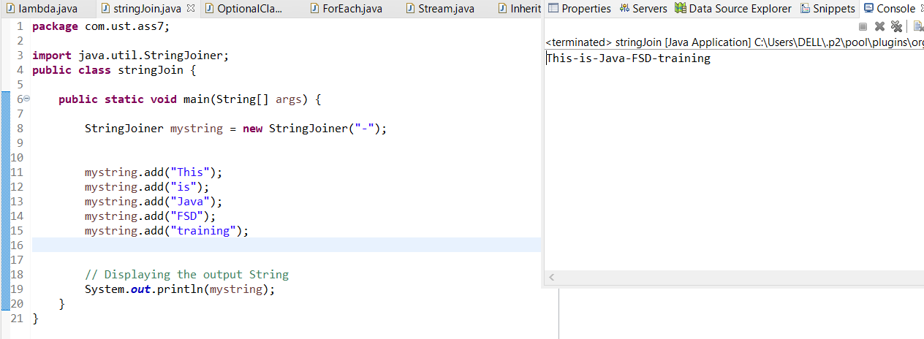

3.

4.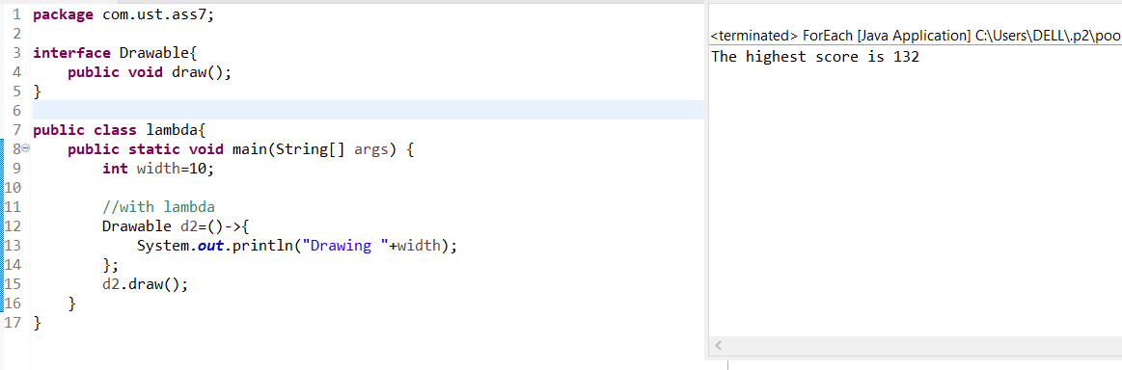

5.

